Exploring the applications of AI among Grade-11 H.E.
Student’s Learning.

A Research Study
Presented to
Mrs. Patrice R. Andales
Isabel National Comprehensive School
Marvel, Isabel, Leyte
,

Research by
Aguilar, Adrian Caz
Rufin, John Lhister
Lopez, Zara Jamilia
Calixtro, Ailyn
Maurillo, Cyfros
Dajalos, Nicole Boyles
Isotto, Kyle Kristoff
Calvez, Ivan

Background of the Study
Artificial Intelligence (AI) is now commonly used in education and has become part of how students learn in school. With the improvement of technology, many students have access to AI tools that help them with schoolwork. These tools include writing assistants, research tools, and learning platforms that support students in understanding lessons and completing academic tasks. However, AI is slowly becoming a regular part of students’ learning experience, especially in secondary education.
In addition, AI is mainly used to assist learning and not to replace teachers in schools. Students often use AI to hn elp gather information, improve written outputs, and understand lessons that they find difficult. These tools provide quick feedback and simple explanations, which can make schoolwork easier to handle. When used properly, AI can help students manage their tasks more efficiently and stay engaged in learning activities.
At the senior high school level, students face heavier academic demands. AI tools can help students cope with these demands by supporting research, idea development, and problem-solving. Many students choose to use AI because it saves time and makes tasks more manageable. However, students do not all use AI in the same way. Their use of AI often depends on their motivation, previous experience with technology, and how useful they think the tools are.
For reference, Ebli, Raimondi, and Gabbrielli (2025) found that high school students’ views on AI-supported learning differ based on their motivation and prior experience with AI. This suggests that students’ background and learning environment affect how they engage with AI tools. Similar studies in K–12 education also show that when AI is properly integrated into classroom instruction, it can lead to higher student engagement and more personalized learning experiences.
Despite these benefits, the use of AI in education also presents several challenges. Not all students have equal access to devices and stable internet connection, which can limit their ability to use AI tools effectively. Another concern is that some students may rely too much on AI when completing academic tasks. In addition, there is often limited guidance on proper and responsible AI use in schools, which may affect how students learn.
In Home Economics, learning involves both written activities and practical tasks related to daily life skills. AI tools may help students with planning, research, and understanding topics such as nutrition, household management, and livelihood skills. However, there are only a few studies that focus on how AI is used by Home Economics students at the senior high school level.
In conclusion, this study focuses on the use of Artificial Intelligence among Grade 11 Home Economics students. It aims to examine how students use AI tools in their learning, how useful these tools are, and the challenges they experience. The study seeks to provide a clearer understanding of AI use in Home Economics education and support better decisions regarding the responsible integration of AI in schools.
Theoretical Background
This study is anchored on the Technology Acceptance Model (TAM) developed by Fred Davis in 1986. TAM explains how people decide to accept and use new technologies based mainly on two things: perceived usefulness (PU) and perceived ease of use (PEOU). Perceived usefulness is basically how much a person believes a technology will actually help them do better or faster, while perceived ease of use is how simple and effortless it feels to use.
In education, TAM has been widely applied to figure out why students choose to adopt or ignore certain digital tools. When learners see a system as helpful and easy to navigate, they’re more likely to engage with it, explore its features, and integrate it into their study routines. On the flip side, if the system seems complicated or doesn’t clearly add value, students may avoid it or only use it reluctantly (Davis, 1989).
Artificial Intelligence (AI) has been changing the game in education. Tools like adaptive learning platforms and intelligent tutoring systems can adjust lessons based on how each student learns, allowing them to study at their own pace. Research shows that when AI is used effectively, it can make learning more interactive, improve problem-solving skills, and even boost motivation. But it’s not just about making school easier—AI also shapes how students collaborate, communicate, and develop critical thinking skills.
Nevertheless, not every student jumps on the AI train the same way. Factors like prior experience with tech, confidence in using digital tools, and personal motivation play a big role. Some students quickly adopt AI because they see it as helpful and straightforward, while others hesitate due to uncertainty or fear of relying too much on technology (Ebli, Raimondi, & Gabbrielli, 2025). This is exactly where TAM comes in—it gives a framework to understand why students make these choices.
In the context of this study, TAM helps explain how Grade 11 Home Economics students interact with AI. By looking at their perceptions of usefulness and ease of use, the study can uncover what encourages them to adopt AI tools, what holds them back, and how these tools affect their learning experience. This framework is useful not only for understanding adoption patterns but also for highlighting potential benefits and challenges students face when using AI in real classroom situations.

Conceptual Framework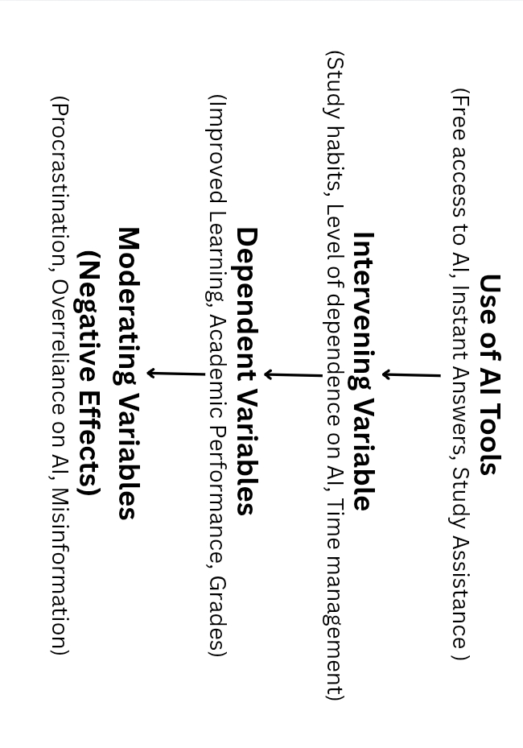
Figure 1: Effects of AI on Education
Figure 1 shows a conceptual diagram illustrating both the positive and negative impacts of AI on students’ learning. On the positive side, AI provides free access, instant answers, and study support, which can lead to improved learning and good academic performance. On the negative side, however, it can encourage procrastination, overreliance, dependence, and misinformation, which may result in reduced self-confidence and affected grades.

Statement of the problem
This study seeks to figure out how AI tools are used by the Grade 11 Home Economics students from Isabel National Comprehensive School.

Specifically, it attempts to answer the following questions.
- How does using AI tools affects student’s study habits?
- Does AI improve student’s academic performance or lead to over-reliance?
- How does AI use affect student’s critical thinking and deep learning ability?
- In what ways has AI served as a ‘creative partner’ on H.E. projects?
- How has the use of AI tools increased student’s proficiency when presenting their projects and outputs?
Significance of the Study
This study is significant as it provides insights into how Artificial Intelligence (AI) is used by Grade 11 Home Economics students and how it influences their learning experiences. The findings of this research may benefit the following groups:
For students, the study can help them better understand how AI tools support their learning, improve efficiency, and address challenges they may encounter when using technology in academic tasks.
For teachers, the results can serve as a basis for improving instructional strategies by identifying effective ways to integrate AI into teaching while addressing potential issues such as over-reliance and digital skill gaps.
For school administrators, the study can provide useful information for decision-making related to technology integration, resource allocation, and the development of policies that promote responsible and equitable use of AI in schools.
For curriculum developers, the findings may offer guidance on incorporating AI-related competencies into the Home Economics curriculum to better prepare students for modern learning environments.
For future researchers, this study can serve as a reference for further research on AI integration in secondary education, particularly in subject-specific contexts such as Home Economics.
Scope and Limitations of the Study
This research focuses specifically on how Grade 11 Home Economics students specifically in INCS use AI for their schoolwork. It looks at what AI tools are used, how often it is used, and how helpful these tools are for tasks like research, writing, or learning new concepts. The study is limited to the students’ own accounts—there’s no testing or hard measurement of grades or performance. It also only covers common AI apps like writing assistants and learning platforms, leaving out teacher methods, school policies, or deep technical analysis of the AI itself. Because it’s focused on a specific group at a specific time, the results might not apply to other grades, strands, or schools. Plus, since it relies on what students report themselves, there’s a chance of bias in their answer.

Definition of Terms
- Artificial Intelligence (AI) – Refers to computer-based systems or applications that simulate human intelligence, such as learning, reasoning, and problem-solving,
used in this study to support students’ learning activities.
- AI Tools – Digital applications or platforms powered by artificial intelligence, including writing assistants, research tools, and learning support systems that help students complete academic tasks.
- Adaptive Learning Systems – AI-based platforms that adjust learning content, pace, and difficulty based on a learner’s needs and performance.
- Intelligent Tutoring Systems – Computer systems that provide personalized instruction and feedback to learners without direct teacher involvement.
- Student Perception – Refers to students’ views, opinions, and attitudes toward the usefulness and effectiveness of AI tools in their learning process.
- Digital Literacy – The ability of students to effectively and responsibly use digital technologies, including AI tools, for learning and academic purposes.
- Secondary Education – The stage of formal education that includes high school levels, specifically referring to Grade 11 in this study.
- Home Economics Students – Grade 11 students enrolled in the Home Economics strand who are the primary participants of this research.

REVIEW OF RELATED LITERATURE
The integration of Artificial Intelligence (AI) into the educational landscape has shifted from a futuristic concept to a foundational reality in secondary education. This chapter reviews the current literature regarding the applications of AI, its benefits, and the challenges it presents to learners, particularly within the context of vocational and secondary education. By synthesizing global and local research, this review establishes a theoretical and empirical base for understanding how AI impacts the competencies of Grade 11 Home Economics (H.E.) students at Isabel National Comprehensive School.
The Global State of AI in Education Artificial Intelligence in Education (AIEd) is primarily utilized to augment learning rather than replace traditional instruction. Research by Hwang et al. (2020) emphasizes that AI-driven intelligent tutoring systems (ITS) have become instrumental in providing tailored guidance and immediate feedback to students, effectively mimicking one-on-one human tutoring. For Senior High School students, these tools are often categorized into writing assistants, research platforms, and adaptive learning systems that adjust the difficulty of content based on student performance. In the Philippine setting, the adoption of these technologies is seen as a response to the heavy academic demands of the K-12 curriculum, where students seek digital support to manage complex technical-vocational requirements while navigating limited physical resources.
The Technology Acceptance Model (TAM) The adoption of AI among students is frequently analyzed through the Technology Acceptance Model (TAM), which has been significantly updated to reflect the generative AI era. According to Farhat et al. (2024), the model posits that "Perceived Usefulness" and "Perceived Ease of Use" remain the foundational drivers of technology integration, but they are now heavily influenced by "AI Anxiety" and "Trust." Recent studies suggest that students generally view AI tools as highly intuitive and accessible, which directly correlates to a high behavioral intention to use them for academic purposes. For Home Economics students, the ease of using AI to generate project ideas or organize livelihood research makes it a high-utility asset that quickly integrates into their study routines.
AI in Vocational and Technical Learning In the context of vocational strands such as Home Economics, AI serves as a bridge between theoretical knowledge and practical application. Chiu (2021) explores how digital tools support student engagement in blended learning environments, noting that AI can provide virtual simulations of real-world tasks. This is particularly relevant for H.E. students who deal with curriculum areas such as household management and livelihood skills. AI-driven platforms allow these learners to simulate budgeting, meal planning, and inventory management, providing a "safe-to-fail" environment where they can refine their technical skills before applying them in physical laboratory settings. This simulated experience is vital for Grade 11 students who are preparing for National Competency (NC) assessments.
The primary benefit of AI integration identified in the literature is Personalized Learning and Adaptivity. Unlike traditional one-size-fits-all instruction, AI algorithms analyze individual student data to tailor educational content to a specific learner's needs. Zawacki-Richter et al. (2019) found that this adaptivity ensures students receive the appropriate level of challenge, which is vital for SHS students who may have varying levels of prior knowledge in technical subjects like nutrition or consumer chemistry.
Secondly, AI offers Immediate Feedback and Continuous Support. In a typical classroom, a student might wait days for a teacher to grade an assignment, but AI provides real-time corrections. Molenaar (2022) notes that this instantaneous feedback allows students to correct misconceptions immediately, fostering a more fluid and less frustrating learning experience during independent study sessions. This is particularly useful for H.E. students who often work on independent practical projects at home.
The third advantage is Enhanced Efficiency and Task Automation. By automating repetitive tasks such as data gathering, basic formatting, and preliminary research, AI allows students to focus on "higher-order" cognitive tasks. Kuhail et al. (2023) highlight that chatbots and AI assistants act as administrative aids, helping students organize their project outlines and manage their heavy academic workloads more effectively. This efficiency enables students to spend more time on the hands-on application of their vocational skills.
Fourthly, AI tools promote Increased Accessibility and Inclusivity. Features such as speech-to-text, real-time translation, and text simplification empower students with different learning needs or language barriers. Zhang and Aslan (2021) argue that AI acts as an equalizer, ensuring that students from diverse backgrounds can access the same curriculum materials and participate fully in the digital classroom. This accessibility is essential in the Philippine public school system, where classrooms often cater to a wide range of learner profiles.
Finally, AI integration fosters Innovative Pedagogy and Student Engagement. AI platforms enable student-centered teaching methodologies that allow for interactive problem-solving. Chen et al. (2020) explain that AI-powered simulations make abstract concepts tangible, increasing the student’s overall interest and motivation to explore complex subjects. For H.E. students, this means being able to visualize the results of different household management strategies or business models in a dynamic way.
A major concern identified in recent scholarship is Cognitive Over-reliance and Dependency. When students place too much trust in automated responses, they may stop engaging with the foundational material. Seo et al. (2021) warn that this dependency can lead to a decline in independent study habits and a failure to develop the persistence required for traditional academic success. If students rely on AI to solve every budgeting problem in H.E., they may find themselves unable to perform these calculations during actual practical assessments.
Linked to this is the Erosion of Critical Thinking Skills. Empirical findings by Dwivedi et al. (2023) suggest that the ease of obtaining "instant answers" encourages a passive learning style. Their research indicates that students often exhibit "epistemic laziness," accepting AI-generated outputs without questioning their accuracy, which negatively impacts their ability to synthesize information and reason independently. This is a critical risk for Senior High School students who must develop the ability to think critically as they prepare for professional life or higher education.
The third disadvantage involves Ethical Risks and Academic Integrity. The rise of generative AI has created significant challenges regarding plagiarism and the authenticity of student work. Chan (2023) emphasizes that the use of AI to generate entire essays or reports undermines the ethical standards of education and necessitates new forms of "AI Literacy" and assessment. Educators must now find ways to verify that students are actually learning the competencies required by their strand, rather than simply prompting a machine to generate the final output.
Furthermore, AI systems are prone to Algorithmic Bias and Misinformation. AI is only as accurate as its training data; if the data is flawed, the AI will produce "hallucinated" or incorrect information. The OECD (2023) points out that students often lack the digital literacy to fact-check AI outputs, which can lead to the acquisition of incorrect technical knowledge. In Home Economics, this could lead to incorrect nutritional data or safety information being presented as factual.
Lastly, there is the risk of Social Isolation and the Digital Divide. Over-reliance on digital interfaces can reduce meaningful human interaction between students and teachers. Additionally, recent analyses highlight that infrastructural gaps mean that students in rural areas may lack the high-speed internet required to access these tools, potentially widening the educational gap between different socioeconomic groups (Vesna et al., 2025; Manila Times, 2025). This is a reality in local communities like Isabel, Leyte, where internet stability varies greatly.
In summary, the literature indicates that while AI is a transformative force for Grade 11 H.E. students, its success depends on a balanced approach. The benefits of personalization and efficiency are clear, but they must be weighed against the risks of dependency and the loss of critical thinking. For the students of Isabel National Comprehensive School, the research suggests that AI should be used as a "scaffolding" tool—supporting the learning process without replacing the essential cognitive and manual work required in the Home Economics strand.

REFERENCES:
- Chen, L., Chen, P., & Lin, Z. (2020). Artificial intelligence in education: A review. IEEE Access, 8, 75264-75278. https://doi.org/10.1109/ACCESS.2020.2988510
- Chiu, T. K. (2021). Digital support for student engagement in blended learning based on self-determination theory. Computers in Human Behavior, 124, 106909. https://doi.org/10.1016/j.chb.2021.106909
- Dwivedi, Y. K., et al. (2023). “So what if ChatGPT wrote it?” Multidisciplinary perspectives on opportunities and challenges of generative AI. International Journal of Information Management, 71, 102642. https://doi.org/10.1016/j.ijinfomgt.2023.102642
- Farhat, J., et al. (2024). Investigating the drivers of students' intention to use generative AI: An extended TAM. Computers and Education: Artificial Intelligence, 6, 100222. https://doi.org/10.1016/j.caeai.2024.100222
- Hwang, G. J., Xie, H., Wah, B. W., & Gašević, D. (2020). Vision, challenges, roles and research issues of AI in education. Computers and Education: Artificial Intelligence, 1, 100001. https://doi.org/10.1016/j.caeai.2020.100001
- Kuhail, M. A., et al. (2023). Role of AI chatbots in education: systematic literature review. International Journal of Educational Technology in Higher Education, 20, 56. https://doi.org/10.1186/s41239-023-00426-1
- Molenaar, I. (2022). Towards hybrid human-AI learning technologies. European Journal of Education, 57(4), 632-645. https://doi.org/10.1111/ejed.12527
- OECD. (2023). Algorithmic bias: the state of the situation and policy recommendations. In OECD Digital Education Outlook 2023. https://www.oecd.org/en/publications/oecd-digital-education-outlook-2023_c74f03de-en/full-report/algorithmic-bias-the-state-of-the-situation-and-policy-recommendations_a0b7cec1.html (Open access report section)
- Seo, K., et al. (2021). The impact of AI on learner agency and dependency in self-paced learning. Frontiers in Education, 6, 623029. https://doi.org/10.3389/feduc.2021.623029
Vesna, L., et al. (2025). Digital Divide in AI-Powered Education: Challenges and Solutions for Equitable Learning. Journal of Information Systems Engineering and Management, 10(21s). https://jisem-journal.com/index.php/journal/article/view/3327
- Zawacki-Richter, O., et al. (2019). Systematic review of research on artificial intelligence applications in higher education. International Journal of Educational Technology in Higher Education, 16(1), 39. https://doi.org/10.1186/s41239-019-0171-0
- Zhang, K., & Aslan, A. B. (2021). AI technologies for education: Recent research & future directions. Computers and Education: Artificial Intelligence, 2, 100025. https://doi.org/10.1016/j.caeai.2021.100025
- Chan, C. K. Y. (2023). A comprehensive AI policy education framework for university teaching and learning. International Journal of Educational Technology in Higher Education, 20(1), 38. https://doi.org/10.1186/s41239-023-00408-3
- Manila Times. (2025). Experts warn AI could widen digital divide in the Philippines. https://www.manilatimes.net/2025/09/28/business/sunday-business-it/experts-warn-ai-could-widen-digital-divide-in-the-philippines/2191484

